Part 1
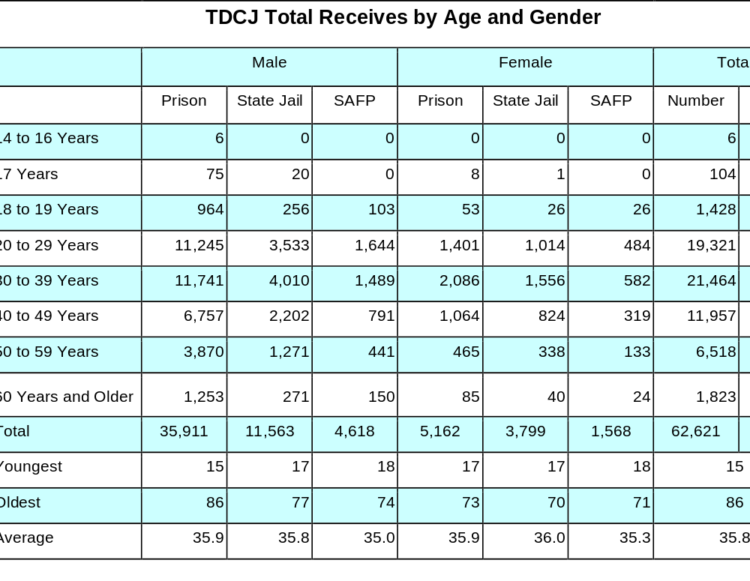
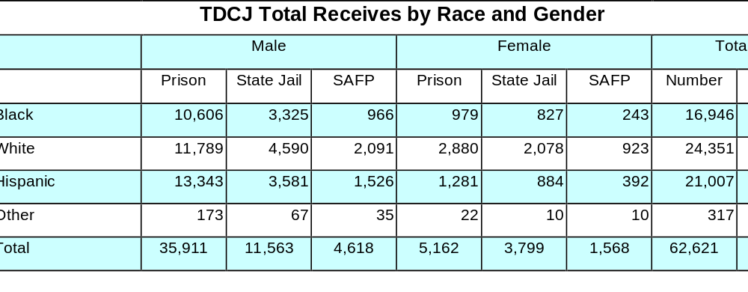

Part 2

[Assignment Name]
[Student Name]
[Class]
Texas Southmost College
[Date]

